**Maintenance of Thyristor Module**

**Muhammad Shamaas**

**The Thyristor Valve Module**

The Thyristor Module consists of 15 Thyristors (5’’, ETT, 8500V/ 3200A) and their associated control and protection equipment. The TCE controls the firing of the Thyristors. The Water pipes and heat sinks prevent the overheating of the Thyristors. Snubber Capacitors (1.4uF) and Snubber Resistors (40Ohm) prevent the Thyristors from malfunction due to sharp current/voltage spikes.

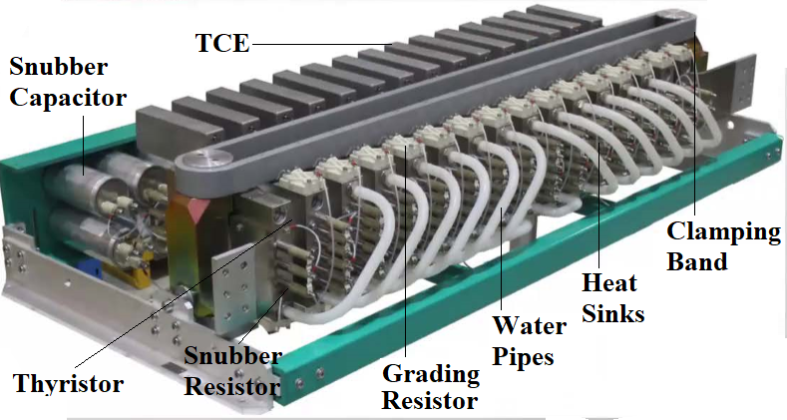

**Circuit Diagram**

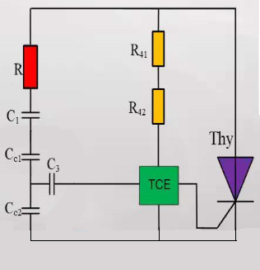

**Maintenance of Thyristor Module**

**Tools and Equipment**

1. An end pressurizing tool with manual hydraulic pump.
2. Grinding tool
3. Radiator Spreader Block
4. Long nose pliers
5. A Thyristor lifting belt
6. Wrenches
7. Screwdrivers
8. Thyristor Level test instruments and related accessories including grounding cables.
9. Anhydrous Alcohol
10. Lint free paper
11. P600 sandpaper
12. Silicone oil.

**Procedure**

|  |  |  |
| --- | --- | --- |
| 1. | Place the Thyristor module on the maintenance platform using a harness and crane. Disconnect the cable connecting Thyristor gate and TCE. |  |
| 2. | Place the end pressurizing tool on the right end plate of the valve assembly. Connect the hydraulic pump attached to the spreading tool, pressurize it to the specified value and close the pressure relief valve when applying pressure. Read the pressure gauge of the hydraulic pump of the end pressurizing tool. |  |
| 3. | Rotate the clamping nut in the right end plate to the left of the valve assembly until it cannot rotate. Then rotate it back for 1-2 turns. Before rotating, draw a marking line between the clamping nut and the right end plate. Place two radiator expansion blocks diagonally between radiators on both sides of the fault Thyristor. |  |
| 4. | Slowly loosen the pressure relief valve on the hand pump connected to the end pressurizing device. |  |
| 5. | Ensure that there is enough distance between radiators (between 38-40 mm) to ensure that the Thyristor can be separated from radiators and replaced. |  |
| 6. | Remove the four fixing screws at the upper clamping band, remove the clamping band and set it aside. |  |
| 7. | Wrap the faulty Thyristor with lifting belt, lift the lifting belt and then remove the Thyristor. |  |
| 8. | Place the Thyristor on paper. Drop alcohol on the upper surface and polish it gently with sandpaper. Polish the other surface as well. Coat the upper surface with alcohol and wipe it with lint-free paper. Keep on repeating until the surface is clean. Repeat this process for the other side as well. Drip 0.5ml of silicone oil on each side surface and coat evenly with lint-free paper. |  |
| 9. | Put the Thyristor in the proper position between the radiators. Rotate it moderately so that the gate connection is in the correct position. Ensure that the polarity of the gate is correct. |  |
| 10. | Install the upper clamping band on the valve assembly and tighten four screws using screwdriver. |  |
| 11. | Remove the radiator spreading block. Close the pressure relief valve of the hydraulic pump of the spreading tool. Increase the pressure until the clamping force reaches the specified value. Rotate the clamping nut to the right during pressurization. When the clamping force reaches 135kN, tighten the clamping nut with a large wrench. Unload the pressure on the disassembly tool and unload the pressurizing tool |  |
| 12. | Connect the gate pole line to the TCE. Remove all equipment from the valve assembly. |  |